|  |  |
| --- | --- |
| Name: | Prerna Sunil Jadhav |
| Sap  Id: | 60004220127 |
| Class: | T. Y. B.Tech (Computer Engineering) |
| Course: | Data Mining and Warehouse Laboratory |
| Course Code: | DJ19CEL501 |
| Experiment  No.: | 06 |

**AIM:** Implementation of Association rule mining Using

1. Apriori Algorithm

2. FP Tree

APRIORI ALGORITHM

CODE:

import pandas as pd

import numpy as np

import math

transaction_df = pd.read_csv('GroceryStoreDataSet.csv')

transaction_df

transaction_df.index.rename('TID', inplace=True)

transaction_df.rename(columns={'MILK,BREAD,BISCUIT' : 'item_list'}, inplace=True)

trans_df = transaction_df.item_list.str.split(',') trans_df

def prune(data,supp):

df = data[data.supp_count >= supp] return df

def count_itemset(transaction_df, itemsets): count_item = {}

for item_set in itemsets:

set_A = set(item_set) for row in trans_df:

set_B = set(row)

if set_B.intersection(set_A) == set_A: if item_set in count_item.keys():

count_item[item_set] += 1

else:

count_item[item_set] = 1

data = pd.DataFrame()

data['item_sets'] = count_item.keys()

data['supp_count'] = count_item.values() return data

def count_item(trans_items):

count_ind_item = {}

for row in trans_items:

for i in range(len(row)):

if row[i] in count_ind_item.keys():

count_ind_item[row[i]] += 1

else:

count_ind_item[row[i]] = 1

data = pd.DataFrame()

data['item_sets'] = count_ind_item.keys()

data['supp_count'] = count_ind_item.values() data = data.sort_values('item_sets')

return data

def join(list_of_items): itemsets = []

i = 1

for entry in list_of_items:

proceding_items = list_of_items[i:] for item in proceding_items:

if(type(item) is str): if entry != item:

tuples = (entry, item) itemsets.append(tuples)

else:

if entry[0:-1] == item[0:-1]: tuples = entry+item[1:]

itemsets.append(tuples)

i = i+1

if(len(itemsets) == 0): return None

return itemsets

def apriori(trans_data,supp=3, con=0.5): freq = pd.DataFrame()

df = count_item(trans_data) while(len(df) != 0):

df = prune(df, supp)

supp)):

if len(df) > 1 or (len(df) == 1 and int(df.supp_count >= freq = df

itemsets = join(df.item_sets)

if(itemsets is None): return freq

df = count_itemset(trans_data, itemsets) return df

freq_item_sets = apriori(trans_df, 5) freq_item_sets

def calculate_conf(value1, value2):

return round(int(value1)/int(value2) * 100, 2) def strong_rules(freq_item_sets, threshold):

confidences = {}

for row in freq_item_sets.item_sets: for i in range(len(row)):

for j in range(len(row)): if i != j:

tuples = (row[i], row[j]) conf =

calculate_conf(freq_item_sets[freq_item_sets.item_sets == row].supp_count,

count_item(trans_df)[count_item(trans_df).item_sets == row[i]].supp_count)

confidences[tuples] = conf

conf_df = pd.DataFrame()

conf_df['item_set'] = confidences.keys()

conf_df['confidence'] = confidences.values()

return conf_df[conf_df.confidence >= threshold] confidence_threshold = int(input()) #50

strong_rules(freq_item_sets, threshold=confidence_threshold)

# ### Rules with confidence level >= 50.0%

from functools import reduce

import operator

def interesting_rules(freq_item_sets):

lifts = {}

prob_of_items = []

for row in freq_item_sets.item_sets:

num_of_items = len(row)

prob_all = freq_item_sets[freq_item_sets.item_sets ==

row].supp_count / 18

for i in range(num_of_items):

prob_of_items.append(count_item(trans_df)[count_item(trans_df).ite

m_sets == row[i]].supp_count / 18)

lifts[row] = round(float(prob_all / reduce(operator.mul,

(np.array(prob_of_items)), 1)), 2)

prob_of_items = []

lifts_df = pd.DataFrame()

lifts_df['Rules'] = lifts.keys() lifts_df['lift'] = lifts.values()

return lifts_df

int_rules = interesting_rules(freq_item_sets)

int_rules

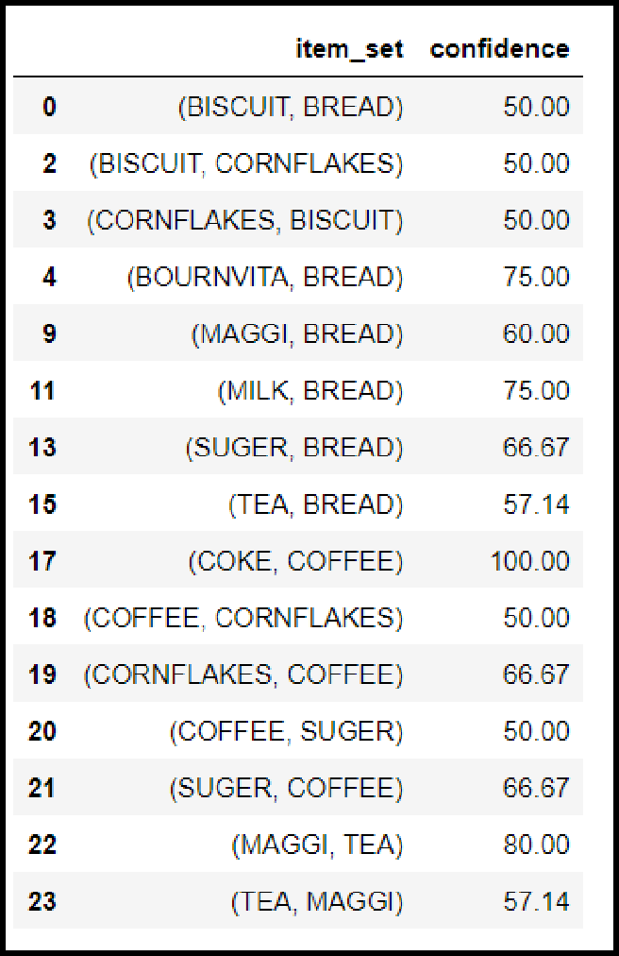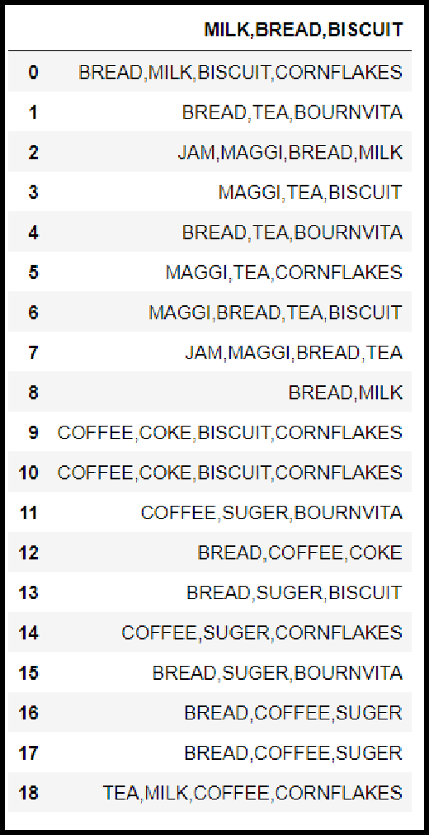OUTPUT:

FP TREE ALGORITHM

CODE:

import pandas as pd

from mlxtend.preprocessing import TransactionEncoder from mlxtend.frequent_patterns import fpgrowth

dataset = [['f', 'a', 'c', 'd', 'g', 'i', 'm', 'p'],

['a', 'b', 'c', 'f', 'l', 'm', 'o'],

['b', 'f', 'h', 'j', 'o', 'w'],

['b', 'c', 'k', 's', 'p'],

['a', 'f', 'c', 'e', 'l', 'p', 'm', 'n']]

te = TransactionEncoder()

te_ary = te.fit(dataset).transform(dataset)

df = pd.DataFrame(te_ary, columns=te.columns_)

df

fpgrowth(df, min_support=0.6, use_colnames=True, verbose=2) # 3/5

= 60%

OUTPUT: